DIY Surgical Mask Pattern

By saramaker.com
The finished adult mask will be 7.75″ wide and 3.75″ tall.
View the full video tutorial on Youtube!

Materials
- 100% cotton fabric (with a tight weave)
- 1/8″ flat elastic for ear loops, or 4 fabric ties (you can use the same cotton fabric to make strips, use pre-made bias binding, or strips of cotton jersey)
- fabric scissors
- ruler
- pins or clips
- sewing machine and thread

Cut List
For an adult size mask:
- Cut 1 fabric rectangle 16″ long and 8.5″ wide
- Cut 2 pieces of elastic, each 7″ long
For a child-size mask:
- Cut 1 fabric rectangle 14″ long and 6.5″ wide
- Cut 2 pieces of elastic, each 6″ long
For elastic ear loops:
- Cut 2 7″ long pieces for an adult mask
- Cut 2 6″ long pieces for a child mask
For fabric ties, if you aren’t using elastic:
- Cut 4 rectangles 18″ long by 1.75″ wide. Fold the long sides to meet in the middle, then fold in half again to encase the raw edges. Stitch down the length of the rectangles along the edge to create the ties.
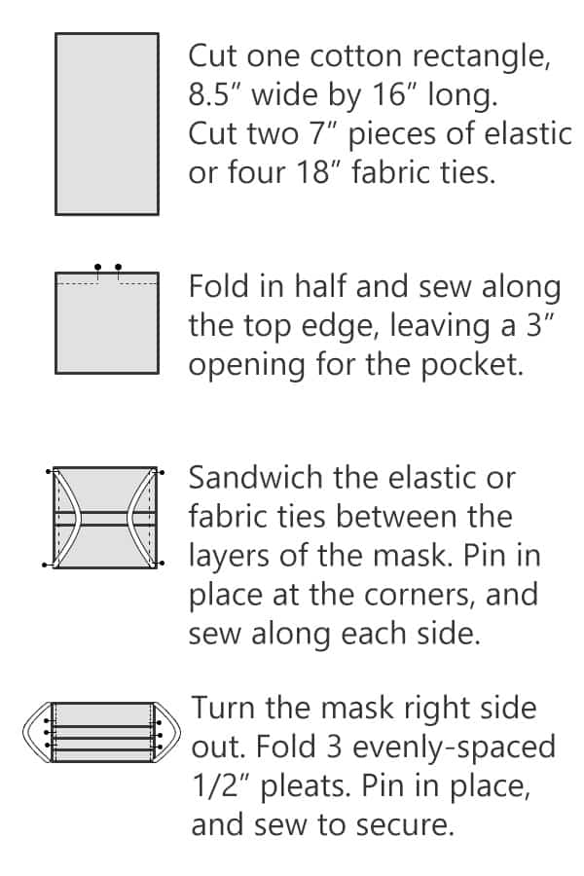

Step 1: Sew to the top side, with pocket
Fold the fabric rectangle in half, with the right sides facing each other.
Sew along the top 8.5″ width edge, using a large 5/8″ seam allowance. Leave a 3” opening in the center of this seam to create an opening for the filter pocket, and to allow the mask to be turned right side out after sewing. In the picture above, I’ve marked this opening with pins.
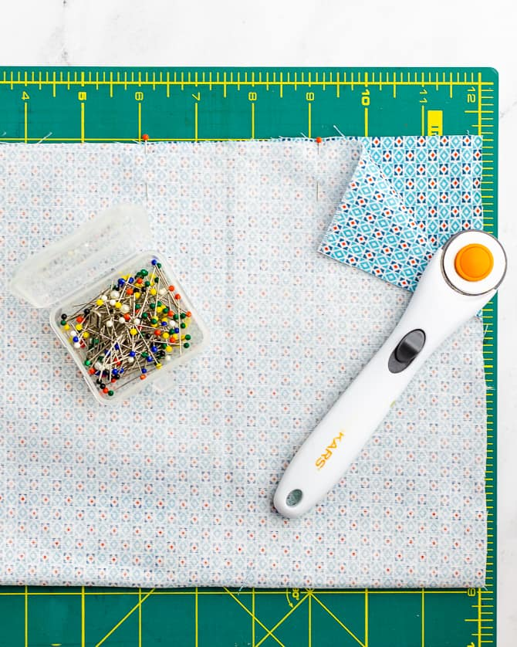
Don’t want a filter pocket? If you don’t want or need a pocket, that’s totally fine. You will still need to leave an opening so that you can turn the mask right side out. After you’ve attached the elastic or ties (in the next step) and turned the mask right side out, you can stitch the opening closed. Then you can continue with the rest of the directions.
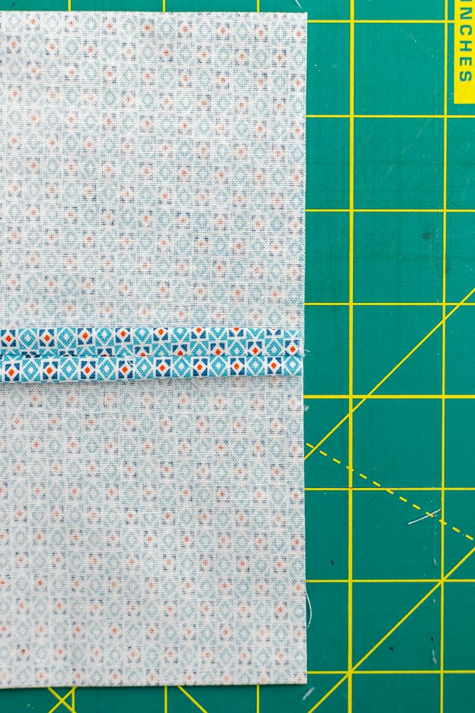
Next, turn the fabric so that the seam with the pocket opening is centered in the middle of one side. Using an iron, press the seam open.
Fold the excess seam allowance under, encasing the raw edge of the fabric. Topstitch or zig-zag stitch along each side of this seam to finish the edge. This will help keep the fabric from fraying when you insert and remove any filters.
See the next photo or the video for clarification.
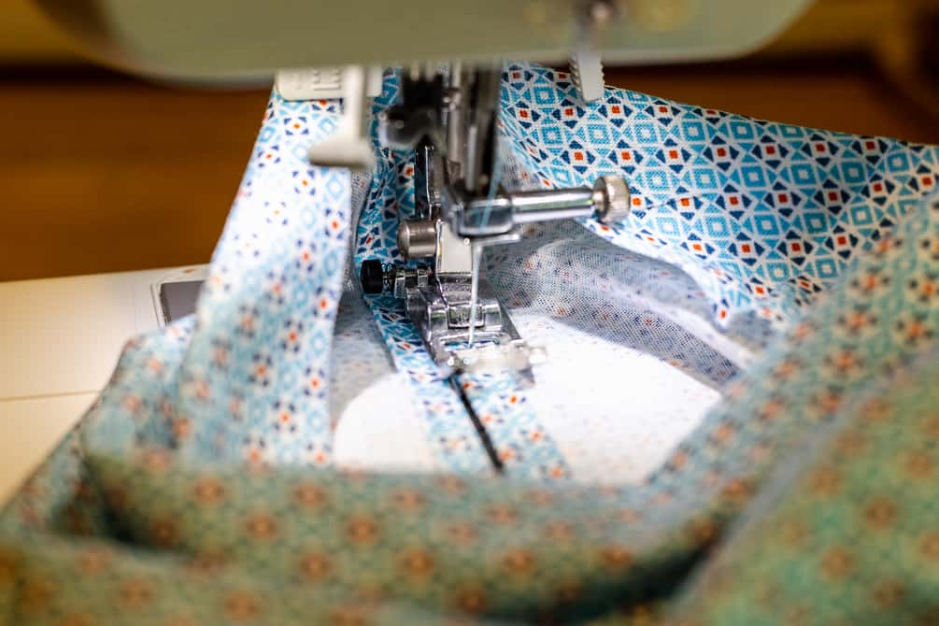

Step 2: Pin Elastic or Fabric Ties
If Using Elastic:
Pin one piece of elastic to each side of the mask, one end to the top corner and one end to the bottom corner of the fabric rectangle. This will create the ear loop once the mask is turned right side out and pleated. Place the ends of the elastic about 1/4 “ from the top and bottom corners of the fabric.
The piece of elastic itself will be sandwiched between the two layers of fabric. Once you turn the mask right side out, the elastic will be on the outside.
Repeat this process on each side to make two ear loops.
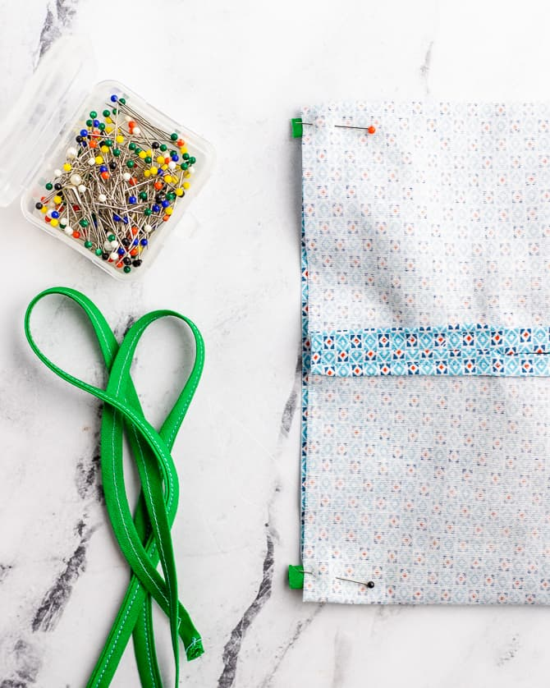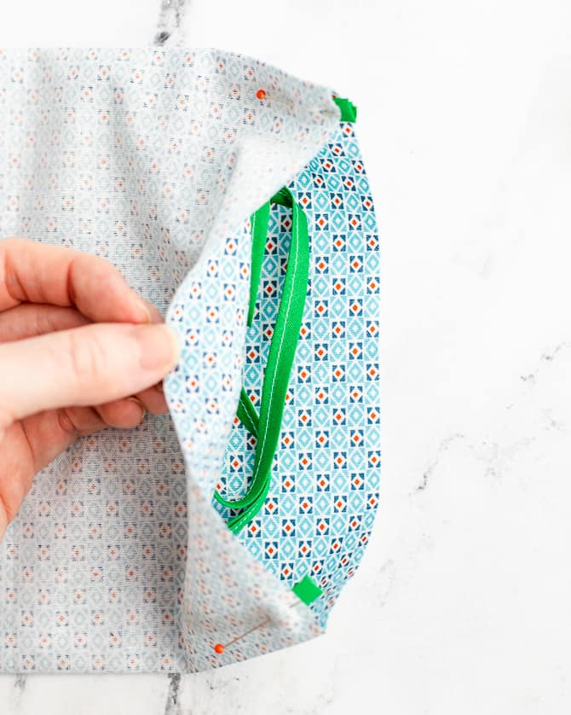

Alternative – Use fabric ties:
If you can’t find elastic, or prefer to use fabric ties, you can use 4 fabric ties, one in each corner. Each tie will be 18″ long. Sew one tie in each corner, being careful not to catch the ties in the side seams.
You can also use twill tape, bias tape, or strips from cotton jersey (t-shirt fabric).
The finished mask will then be worn by tying the fabric strips behind the head. See notes at the bottom of the post.

Step 3: Sew the Sides, Securing the Ties
With a 3/8″ seam allowance, sew each side of the facemask. Backstitch over the elastic or fabric ties to secure them. Trim the corners with scissors so that it will be easier to turn the mask right side out. Becare not to accidentally clip the stitches.
Turn the mask right side out and press with an iron. You can use a pencil to push out the corners.
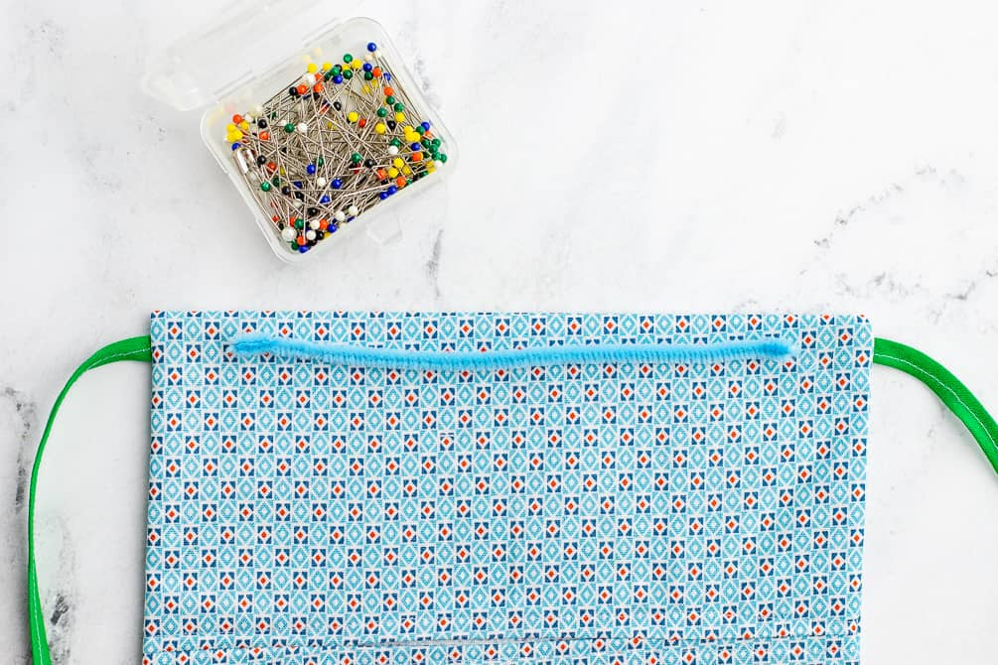

Optional: Insert a Flexible Nose Piece
Cut a 6-inch piece of pipe cleaner or other flexible wire to create a nose piece. I folded the ends of wire back into to keep them from poking through the fabric. Place the wire through the pocket hole and slide it up to the very top of the mask. Stitch around it on all 3 sides to keep it in place.
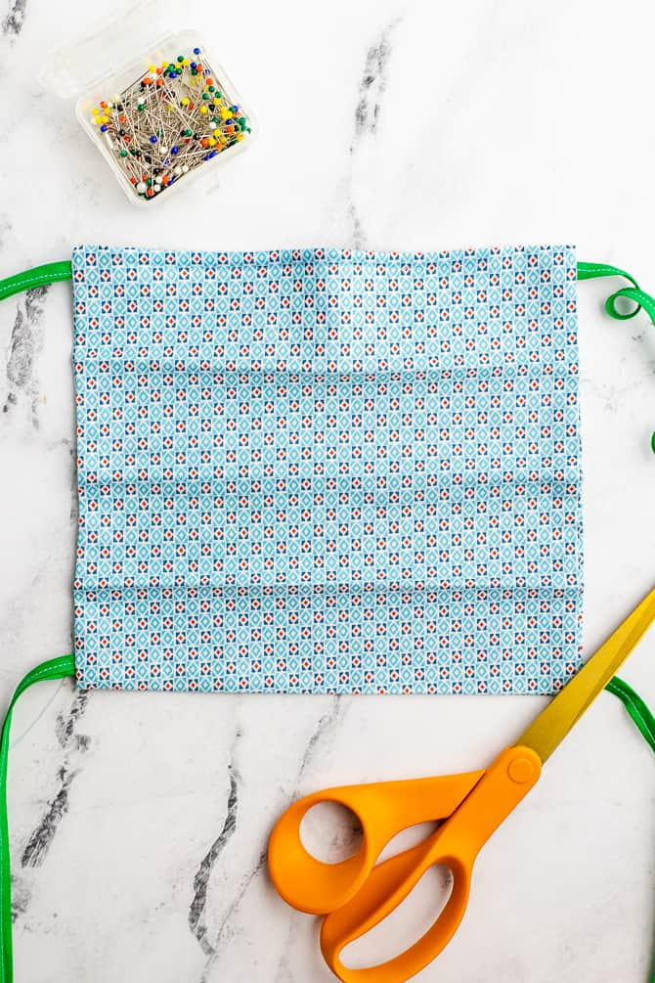

Step 4: Make the Pleats
Make the mask with three evenly spaced lines. To do this, you can measure and mark with a water-soluble fabric pen. Or, you can do what I did, and fold the mask in quarters – fold the sides to meet in the middle, and then fold again in half. Use an iron to make a crease.
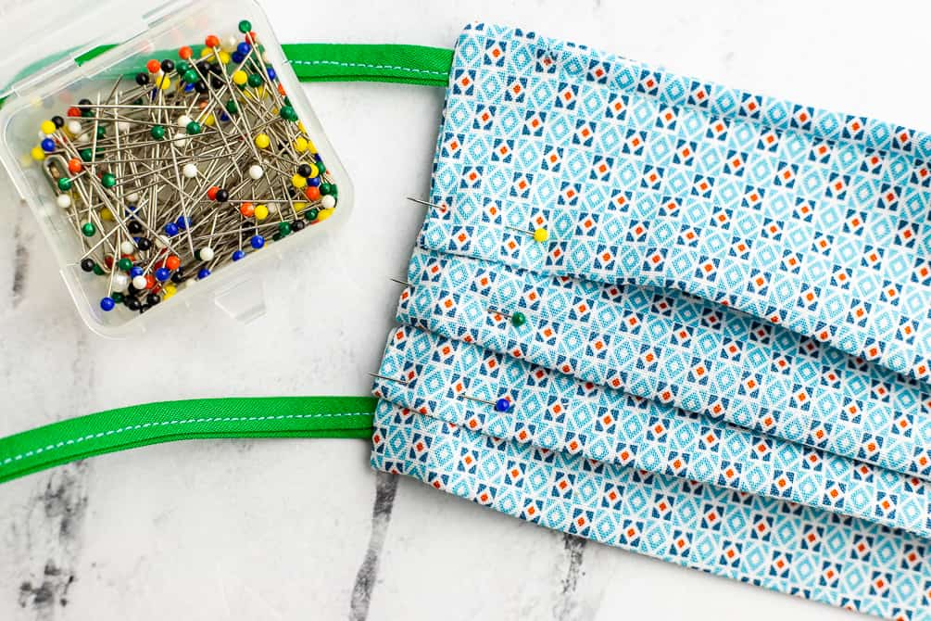
Use your markings to create three evenly spaced 1/2” pleats. Pin the folds down, make sure all pleats are facing the same direction. Sew along the sides to secure the pleats. I like to sew down the sides twice, just to make sure.
When the mask is worn, the pleats should open downwards to prevent any particles from collecting in the fold pockets.
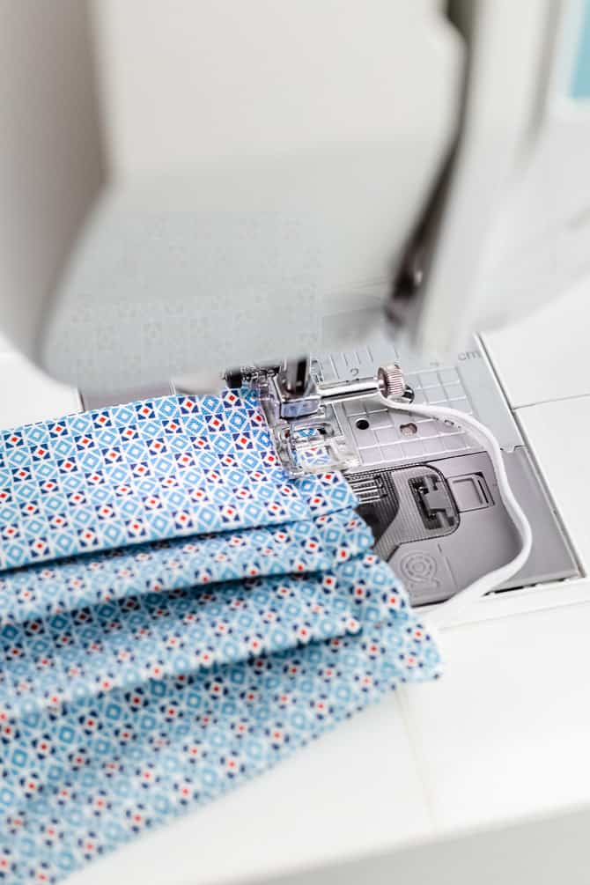

Troubleshooting the Pattern

Can’t find elastic?
I’ve heard from many people that are having a hard time finding elastic. If you can’t find elastic to make the ear loops, you can make a mask with fabric ties instead. You can use ready-made 1/4″ twill tape, double-fold bias tape, or cut long strips of the same tightly woven cotton fabric you are using for the rest of the mask.
To make bias binding fabric ties: Cut 18″ long strips of fabric, 1.75″ wide. Fold the long sides together (lengthwise or hot-dog style) so that they meet in the middle. Then fold the strips in half again (lengthwise) to encase the raw edges. Stitch down the strips along the edge to create the ties.
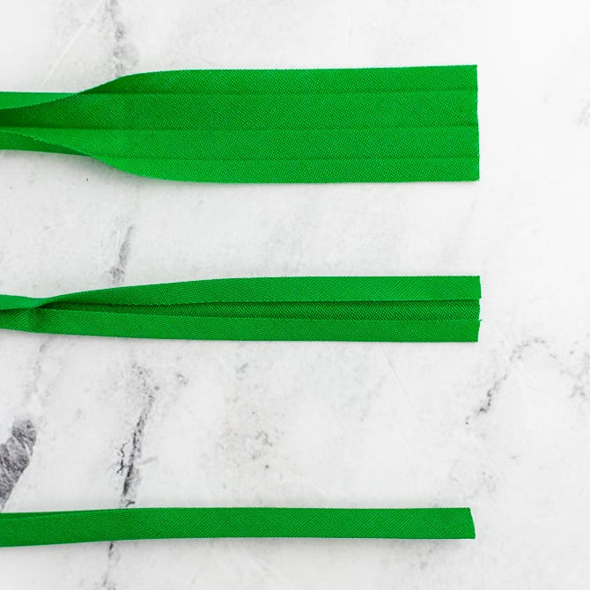
If you wanted these straps to have a bit of stretch, you could also cut long strips from cotton jersey or knit T-shirt material. The great thing about using jersey fabric is that it will form itself into a tube when you stretch it. And, it’s comfortable to wear since it keeps a bit of stretch.
Whichever option you choose, you’ll want to cut 4 pieces about 18″ long, and attach one strip to each of the corners. The mask will fasten by tying the straps behind the head.

What about metal to help the mask fit better?
To help the mask fit better around your nose, you can insert a length of flexible metal to the top inside of the mask, through the pocket insert opening before forming the pleats. Then, you can topstitch down around the metal insert so that it stays in place. I’ve seen people use pipe cleaners, floral wire, or twist ties.

What can you use as a filter?
It is so important that everyone understands that while wearing a cloth face mask can offer some level of protection, it can’t protect against viruses the same way that an N95 mask can.
In testing, a layer of HEPA vacuum cleaner bag or HEPA air filter seems to perform the best. However, it will be harder to breathe through.
If you are sewing for hospitals, they may have their own medical grade filters. Always call before you sew to check their requirements.
Disclaimer: This pattern has not been industry-tested and is intended for educational purposes only. The decision to use this device is solely your own.

Where can you donate masks?
Not all hospitals are requesting masks, but many are. Search your local hospital to see if they have requested donations.
Also, an organization called Masks for Heroes has a website with a searchable database of facilities currently seeking donations. If you are wondering where you can donate masks, they can help you find a hospital or clinic that needs them

